**NEWSLETTER**

**AUGUST 2022**

**LEWISTON MOOSE LODGE 2495**

**Phone: 989-786-4388**

**Fax: 989-786-2791**

**www.lewistonmoose2495.org**

**2022-2023 Officers**

President – Bob Whitbread 3-year Trustee – Andrea Koss

Administrator – Ed Umstead 2-year Trustee – Barry Longenour

Vice President – Ken Honeycutt 1-year Trustee – Jim Dome

Jr Past President – Harry Pagan Treasurer – Bob McClinton

Chaplin – Janie Heston Sergeant-of-Arms – Kevin O’Keefe

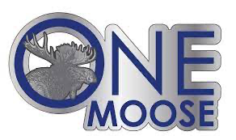

“**A burden heavy to one is borne lightly by many**.” Moose motto

The Moose is about celebrating life together, serving those in need within our local community, supporting our children at Mooseheart and standing by our senior members

August 1, 2022

Our Moose Family,

We had a busy three months with activities and elections. We now have a full board with the new installations of:

Treasurer – Bob McClinton

Chaplin – Janie Heston

1-year Trustee - Jim Dome

2-year Trustee – Barry Lockenour

Thank you for continuing to support our election process and participating in General Membership meetings and voting.

I appreciate all the hard work by our members for the following:

*Clean-up of our grounds and section of County Road 491 (many volunteers)

*Debbie Pagan and Patti Rissman for the work on flower gardens out front

*Lewiston Area Greenhouse owner, Cindy, for providing the flowers at cost

*Vern Rhoades making a generation donation of red mulch

*Rich Castle for donating a new kegerator for our pavilion

*Kitchen volunteers; Polly, Nancy O, Patti, Andrea, Janie, Nancy A, Ginger, Megan

*Weekly lodge cleaners; Polly, Nancy O, Patti

The Classic Car Cruise-in continues to be very successful under the direction of George Denison and Aline Flinn and the support, advertising, and contributions by Mary Becker. There are many volunteers that help weekly, too many to mention. I sincerely thank all the members who come weekly to help with this event.

Recap of the last three months:

*A successful Fiesta Dinner in May

*Mother’s Day gift basket raffle won by Bill Stevens, included $100 in scratch off tickets

*A pasta dinner with either shrimp or chicken in June

*Father’s Day raffle won by Walter Gomton, included $100 in scratch off tickets

*Availability of hot dogs and brats on Friday nights

*Hosted bartender certification in June for northern Michigan

*A great turnout for the steak kabob dinner in July

*Serving pizza by the slice or whole on Saturday nights

*Playground structure donated by a member’s family that will triple in size what we have which will also allow for older children to utilize in addition to the young ones

*Continued growth of our family, getting us close to 500 members

Upcoming events:

*Angels of Action Fundraiser – items needed are posted in the lodge and on our website

*Michigan Moose Conference in Sault Ste Marie, August 16th-20th

*Grilled Butterflied Chicken Dinner, August 13th

*General Membership meeting August 27th (note change in schedule)

*Hayride on Saturday, September 24th at 1 pm

To prevent burnout from our weekly volunteers, if you have any time to help in kitchen, cleaning, or bartending, please consider joining in our success of the “friendliest lodge in the north.”

Sincerely,

Bob Whitbread

President

***You can always find updated information on our Facebook page ‘Lewiston Moose 2495” or the website – lewistonmoose2495.org***

**Moose International News**

It’s 2022 and time for the Moose Fraternity to start using less paper and help to protect the natural habitat of our namesake – The Moose!

Utilizing the technology right at your fingertips, you can start receiving your membership dues notice electronically either by simple text message or in an email.

Once you opt-in to text messaging or an email notice, you’ll be just a simple tap or click away from the Moose International renewal page and paying your dues by credit card in a matter of minutes.

Stay better connected to The Moose Fraternity; get your dues notice electronically and know that you’re helping us all be better stewards of our natural resources.

When you receive the email, click the link provided to opt-in to begin receiving electronic dues notices in the future.

If you need any assistance, our Member Services staff is ready to assist you Monday – Friday from 7am – 4:30pm (CT). Just call us at (630) 906-3658 or email our [Help Desk](mailto:helpdesk@mooseintl.org).

**Moose Fraternity Renews Relationship with NASCAR Driver Ross Chastain**

The Moose Fraternity will once again partner with Ross Chastain as he seeks to capture the NASCAR Cup Series Championship with his new team, Trackhouse Racing.  Last year, Ross raced full-time on the top NASCAR circuit with Chip Ganassi Racing (CGR) in the number 42 Chevrolet Camaro ZL1 1LE.  The Moose was the primary sponsor for four races and an associate sponsor for the remainder of the schedule.

CGR sold its charters to Trackhouse last year, and Ross joined his new team in time for the 2022 season, which begins with The Busch Light Clash at the Los Angeles Memorial Coliseum on February 6th.  The Moose will again be the primary sponsor of the No. 1 Chevrolet Camaro for four races: Talladega (Ala.) Superspeedway on April 24th; Worldwide Technology Raceway near St. Louis on June 5th; Richmond (Va.) Raceway on Aug. 14th; and Martinsville (Va.) Speedway on Oct. 30th.  The Fraternity will also be represented on the car and Ross’s firesuit in all other races during the season.

“Ross is carrying tremendous momentum into the 2022 season and has the enthusiastic support of nearly one million Moose members in his pit box. Ross and the No. 1 crew will be one of the most exciting teams to watch this season.” said Scott Hart, CEO, Moose International. “We are also eager to build a strong partnership with Trackhouse Racing. We know Trackhouse supports our core missions and all of us look forward to reaching out to loyal NASCAR fans across the country.”

The relationship with NASCAR and Chastain, a member of Tice and the Shores, FL Lodge 1287, is intended to raise the profile of the Moose Fraternity to an audience with similar demographics as the current membership.  In conjunction with the local marketing grant program that the Moose Board of Directors approved in 2021, the Moose hopes to drive new member production by being more active within our local communities and more recognizable to a broader national audience.

“I really enjoyed getting to know the team from the Moose Fraternity over the last few years and am honored to be a member of the Moose,” said Chastain.

“It’s great to welcome them to Trackhouse Racing and the No. 1 team in the Cup Series. Their members do a lot of good work in communities across the country, and with everything going on, I can’t think of a better time to help promote what the Moose do and who they are. We are going to have a lot of race fans in 2022 with the Moose support.”

ADVERTISING

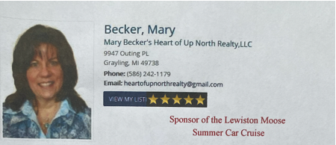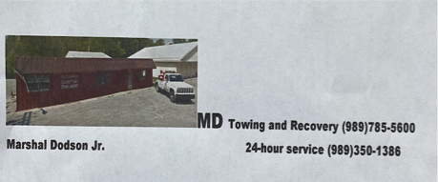

If you would like to advertise in the Moose newsletter, please contact Ed Umstead or Bob Whitbread at **989-786-4388**